Sponsorship Form

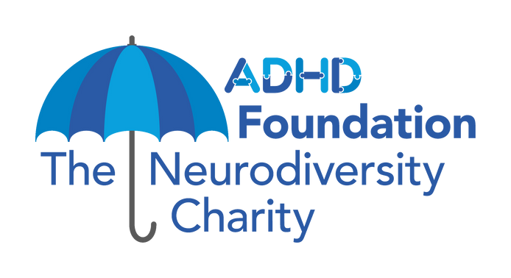
Event Name:
Event Date:
Supporter Group or Business (if applicable):
One in five people are neurodivergent. This umbrella term covers Autism, ADHD, Dyslexia, Dyscalculia, Dyspraxia and Tourette’s Syndrome. Those who are neurodiverse, their families, teachers and employers often struggle to get the support they need to ensure they can thrive.

The ADHD Foundation Neurodiversity Charity aims to create a world that views neurodiversity and ‘thinking differently’ as a strength, whilst acknowledging and understanding the difficulties associated with lifespan neurodevelopmental conditions, and we need your help. Find out more at www.adhdfoundation.org.uk/about-us/

First Name Surname Home Address
(essential for Gift Aid)
Ann |  | Sample |  | 1 Sample St, Sample |  | SM1 1SM |  | 01/01/01 |  | £10.00

Postcode
(essential for Gift Aid)
Date Donation

© The ADHD Foundation Neurodiversity Charity 2023 Registered Charity no 1120898 (England and Wales)
SUBTOTAL RAISED £

First Name Surname Home Address Postcode Date Donation

TOTAL RAISED £

How to get the money to us

Once you have finished your event/activity and collected all your donations you can:

- Make an online transfer to our bank account:
Lloyds Bank, Sort Code: 30-95-11, Account No. 02331633
Please make sure to include your name/details of the event in your payment reference.

- Send a cheque for the full amount made payable to ADHD Foundation to the ADHD Foundation Neurodiversity Charity, 54 St. James Street, Liverpool L1 0AB.

- Head to the Donate section on our website and donate the amount raised!

Data Protection
We use the details you’ve provided to process your donation, including claiming any Gift Aid from HMRC. Your details, and those of your sponsors, are held on our secure database and we promise never to share them with any other organisation for their marketing purposes. You can read our full privacy policy on our website.

Thank you for your support!
© The ADHD Foundation Neurodiversity Charity 2023 Registered Charity no 1120898 (England and Wales)

